Ready to share insurance content
Tools you can customise by Zurich/OnePath Life Insurance

Top 3 things you need to know about TPD

SOCIAL MEDIA
Use or customise the below post most likely to resonate with your clients via social media such as LinkedIn or Twitter. Your posts can link directly to the articles on our website, or you can customise a link to your own white-labelled versions of the articles.
Tip: Spread the word with #insuranceclarity
#insuranceclarity is a hashtag we’ve added to the material to promote life insurance education. We encourage you to get on board and help grow engagement and confidence in the life insurance industry by using it when you post on social media.

SOCIAL MEDIA POST
Total and permanent disability (TPD) cover is one of the more complicated types of life insurance. It’s generally included in insurance inside super and it’s important you understand what you’re covered for and what that means at claim time. Read more #insuranceclarity
<Link to the article below either on your website or within the social platform>

FLYER/NEWSLETTER/WEBSITE ARTICLE
This article has been white-labelled to allow you to use the content (without having to seek our permission but at your sole risk) as a customer flyer, newsletter or on your website.
Tip: Complement your advice
You could also use the articles to complement your advice, sending specific articles to clients who have expressed concerns about their insurance or who have yet to take up insurance you have recommended.

ARTICLE

TPD cover 101
A permanent disability will change what the rest of your life looks like. It can also make life much more expensive in terms of medical care and home modifications. These are part of the reason why total and permanent disablement (TPD) insurance can be so valuable if you suffer a permanent injury or illness.
When you’re looking at TPD insurance, there are 3 important things you need to understand:
- How your claim will be assessed (i.e. any occupation or an inability to undertake certain activities of daily living)?
- How long your claim will take and what is meant by “maximum medical improvement”?
- What impact payment of TPD insurance may have on your linked life insurance?

1. How your claim will be assessed
TPD insurance generally pays a lump sum if an illness or injury leaves you permanently disabled so that you are unable to ever return to any occupation for which you are suited by education, training or experience.
In some cases, there may be an additional requirement based on an inability to undertake certain activities of daily living. This can apply in specific situations, such as where you have not been gainfully employed for a certain period or are not working full-time.
It’s important to check the details of your TPD insurance so you understand what you’re covered for and how to claim.
2. Maximum medical improvement
TPD insurance claims can take longer to pay than other types of life insurance, mainly because of the complexity involved in determining whether a disability is permanent.
Generally, a TPD insurance will only be paid when you obtain “maximum medical improvement”. That means you need to have had any operations, rehabilitation or medical procedures recommended by your treating doctors.
As you can imagine, a TPD cover claim can take months or even years to play out, and it does have a higher decline rate than other cover types because of the difficulty in proving permanency.
TPD insurance also requires that you are unable to return to any occupation for which you are suited by education, training or experience and consideration of potential suitable employment is also carefully considered at the time of claim.

3. How your life cover may be affected
TPD insurance held within your super fund may be a ‘linked policy’ that’s connected to life insurance.
Linked policies mean that payment of a TPD insurance benefit will reduce the life insurance benefit by the same amount.
Say you have $200,000 of TPD insurance in your super account linked to $500,000 of life insurance. If you receive your TPD insurance, your life insurance benefit will reduce by the $200,000 paid out (i.e. to $300,000).
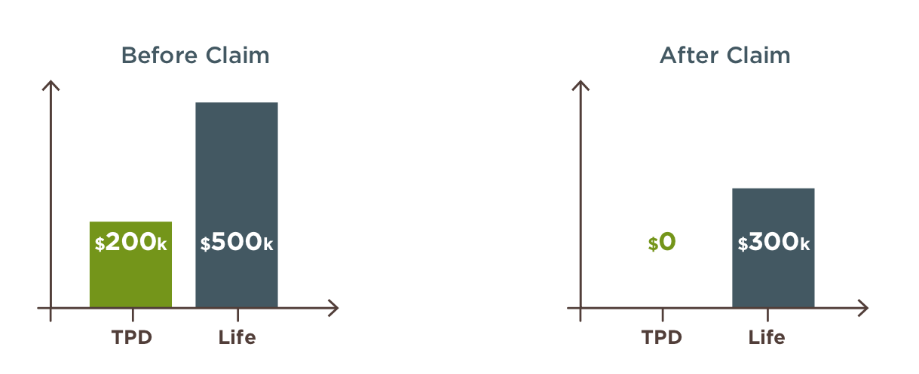
Did you know?
You generally won’t be covered under TPD insurance if your disability is caused by any self-inflicted act. You can find details of any exclusions in the Product Disclosure Statement (PDS).

Want to know more?
If you’d like to discuss any of the content in this article and how it may apply to you, please call me on XXXXXXXXXX.

This information is prepared by [trustee name], the trustee of [Super fund name]. It is current as at [January 2021] but may be subject to change. Updated information will be available by contacting us on/at [details].
The information provided is of a general nature and does not take into account any objectives, needs or financial circumstances. Readers should consider the appropriateness of the information, having regard to your objectives, financial situation and needs and seek financial advice specific to them before making any decision based on this information.
We recommend that you read the relevant Product Disclosure Statement available at [website details] or by contacting us on/at [details] before deciding to acquire, continue, or vary any insurance in [Super fund name].

