Read to share insurance content
Tools you can customise by Zurich/OnePath Life Insurance

Top 3 things you need to know about income protection

SOCIAL MEDIA
Use or customise the below post most likely to resonate with your clients via social media such as LinkedIn or Twitter. Your posts can link directly to the articles on our website, or you can customise a link to your own white-labelled versions of the articles.
Tip: Spread the word with #insuranceclarity
#insuranceclarity is a hashtag we’ve added to the material to promote life insurance education. We encourage you to get on board and help grow engagement and confidence in the life insurance industry by using it when you post on social media.

SOCIAL MEDIA POST
There are a key decisions you need to make when you take out income protection. Here we look at what your options are, and what difference they make at claim time. #insuranceclarity Read more
<Link to the article below either on your website or within the social platform>

FLYER/NEWSLETTER/WEBSITE ARTICLE
This article has been white-labelled to allow you to use the content (without having to seek our permission but at your sole risk) as a customer flyer, newsletters or on your website.
Tip: Complement your advice
You could also use the articles to complement your advice, sending specific articles to clients who have expressed concerns about their insurance or who have yet to take up insurance you have recommended.

ARTICLE
Income protection 101
There's not much you can do without an income. In monetary terms, your ability to earn an income is likely to be your biggest asset - which is why income protection insurance (also known as salary continuance insurance) can be so important.
When considering income protection insurance, there are 3 things you need to understand so you know what you’re covered for, and what that means at claim time:
- How much you’re covered for – amount insured
- How long you need to wait for your claim to be paid – the waiting period
- How long your claim will be paid for – the benefit period

Amount insured

Income protection generally covers a percentage of your before-tax income. This may include super contributions depending on your super fund. This example shows an income protection policy covering 75% of your before-tax income:
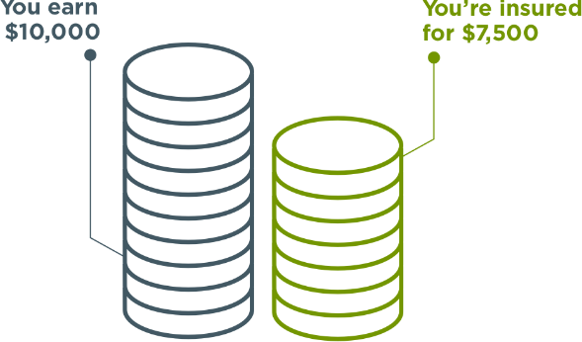
‍The higher your amount insured, the higher your premium will be. So you need to think about how much money you’ll really need to keep up with your everyday expenses (like your rent/mortgage, bills, school fees etc.). Just because this example covers 75% of your income, doesn’t mean you need this level of amount insured.
For example, you might earn $10,000 per month but decide you only need $5,000 per month to keep up with your living costs. That may significantly reduce the cost of your cover (i.e. your premium).
Please note that you cannot be covered for more than your usual income.

2. Waiting period
The waiting period is the number of days you need to wait until you first are entitled to receive income payments. This is calculated from the date it is confirmed that you are disabled and unable to work. Common waiting period options are 30 days, 60 days or 90 days.
However, you should note that income protection payments are usually made monthly in arrears. So if you had a 30-day waiting period, your first payment would be made 60 days after you first became unable to work.
The waiting period affects the premium. Naturally, a policy with a 30-day waiting period is more expensive than the same policy with a 90-day waiting period, because your payments would commence earlier and may not commence at all.
For example, assume you’re disabled and unable to work for 80 days. If your income protection insurance has a 30-day waiting period, you could potentially be paid your amount insured for a total of 50 days. But if you have a 90-day waiting period, you would not be eligible to receive anything.
When choosing an appropriate waiting period, you should think about how soon you’re likely to need financial support if your income stops. For example, if you have access to generous sick leave or annual leave, or a high level of savings, you may be able to take a longer waiting period and reduce your premium.

3. Benefit period
The benefit period is the maximum amount of time you can receive income protection payments for any claim while you are disabled. It can be based on time (e.g. 6 months, 2 years etc.) or age (e.g. to age 65, 70 etc.) and your choice can make a difference to the total amount you receive.
Say you’re aged 40 and you become disabled and are never able to return to work. If you had a 2-year benefit period, your benefit payments would stop when you’re aged 42. But if your benefit period was to age 65, you would continue to receive benefit payments for an additional 23 years.
Choosing a longer benefit period increases your premium because the potential payout is higher. However, be aware the benefit period is the maximum amount of time you can receive payments. If you’re able to return to work (which may be a similar or alternate occupation) sooner than that, or you reach age 65, your payments will stop.
Also, if your policy offers ‘partial disability benefits’, you may be able to return to work part-time and receive reduced payments until you are able to return to full time work. This can be a great benefit to have as you transition back into the workforce after an injury or illness.
Did you know?
You generally won’t be covered under income protection policies if you suffer an injury or illness because of an intentional act. Also, as your cover is held inside super, you’re generally not covered if you suffer an injury or illness while you’re unemployed. Be sure to check out the policy terms and conditions for more information.

Want to know more?
If you’d like to discuss any of the content in this article and how it may apply to you, please call me on XXXXXXXXXX.

This information is prepared by [trustee name], the trustee of [Super fund name]. It is current as at [January 2021] but may be subject to change. Updated information will be available by contacting us on/at [details].
The information provided is of a general nature and does not take into account any objectives, needs or financial circumstances. Readers should consider the appropriateness of the information, having regard to your objectives, financial situation and needs and seek financial advice specific to them before making any decision based on this information.
We recommend that you read the relevant Product Disclosure Statement available at [website details] or by contacting us on/at [details] before deciding to acquire, continue, or vary any insurance in [Super fund name].

